



**You entered the ‘Stories of Survival’ short story competition. The theme of this year’s competition is ‘Nature: friend or enemy?’**

**Write a story about a hiker who gets caught in a storm while hiking in the mountains.**

*Writing topic taken from Paper 2 of the 2022 HKDSE English Language Examination ©HKEAA*

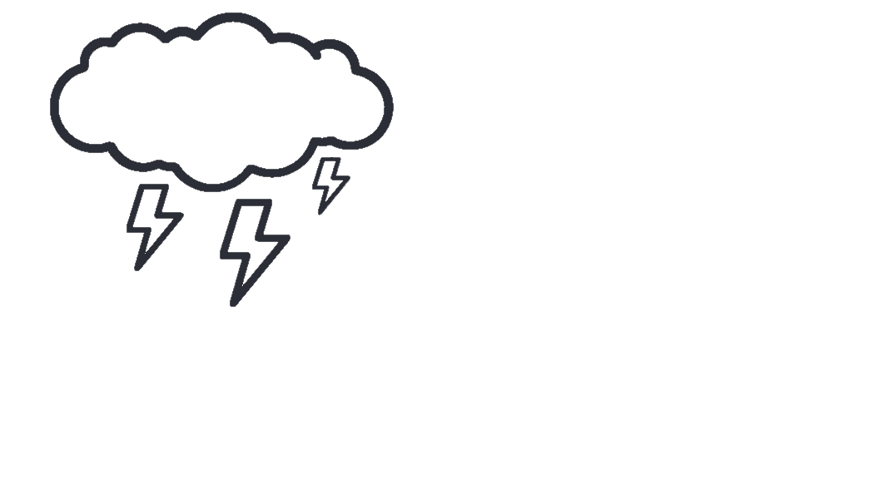

**This is not simply a survival story. The theme “Nature: friend or enemy?” should also be addressed.**

**Topic**

**Story Idea Words**

**Start your story using one of the following strategies.**



**Character Description**

**Describing the Setting**

* spectacular/breathtaking view
* slippery rocks/mossy stones
* rough/rugged steep slopes
* a narrow sandy ridge with sharp drop-offs
* full of dead-ends
* prone to flash floods and dangerous rock falls
* the sky was blackened with thick clouds
* rain poured
* thunders cracked/crashed/  
  boomed/rumbled
* gales howled/whipped bitterly
* lightning struck/flashed/ flickered across the sky



**Setting Description**

5 Falling Action &

6 Resolution

* How did the story end?
* What did the character(s) learn from this incident?

1 Exposition

* Who is/are the character(s)?
* What is the setting of the story?

4 Climax

* What is the most exciting part of the story?
* What is the moment of change?

2 Conflict

* What is the main problem in the story?



3 Rising Action

* How did the character(s) cope with the main problem?
* What further complicated the situation?



**Peak Moment**





**Flashback**



**Dialogue**

**Describing the Ordeal**

* took shelter under the trees
* crouched down
* was drenched/soaked to the skin
* tripped over (something)
* my optimism was waning
* fainted/became semi-conscious
* rescuers coming from a helicopter
* a narrow escape/a close shave

**Describing the Feelings**

* in a panic
* uttered with fear/fright
* yelled/shouted/cried at the top of my voice
* panted breathlessly
* a sense of unease overtook us
* my heart missed/skipped a beat
* got cold feet
* regretted (doing something)

Curriculum Development Institute

Education Bureau HKSAR ©2022

**What are the key events of your story?**